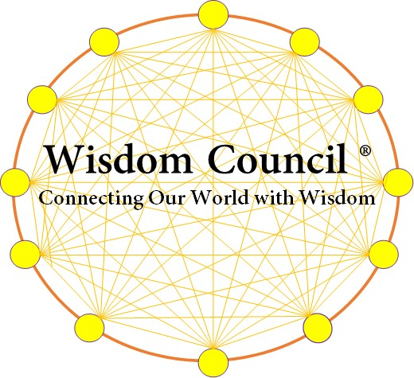

Wisdom Council Application

Assessing Progress to
‘Next Level’ of Significance

Wisdom Council is a unique experience where Council Members convene in circle and discuss their Visions to change the world! Clarify where they’re going! Strategize how to get there! Over four days, each Wisdom Council Member collaborates with the Wisdom Council to build a plan to achieve their ‘Next Level’ of SIGNIFICANCE. Think about it! You’ll have time to actually strategize your path to achieve your monstrous vision and work with Patrick and other Council Members who are changing the way people work and live in our world. One of them may hold the KEY for you to get there faster and with less risk. You may have EXACTLY what another Wisdom Council Member needs to live into their LEGACY! Join us! The first step is to complete this ‘Next Level’ of Significance Assessment!
Please answer the following questions and submit them to support@mosherenterprises.com. Whether you come to the Wisdom Council or not, this is a FANTASTIC way to assess if you’re living INTO your Legacy!
As clearly as you can, briefly describe your Dream, Ambition or Vision?

What are the 3 Biggest Barriers in achieving your Dream, Ambition or Vision?
1.
2.
3.

What are your top 3 goals to achieve by the end of 2019?
1.
2.
3.

What do you need help with right now?

Wisdom Council Application
Assessing ‘Next Level’ Significance
Why do you want a seat at the Wisdom Council?

How can you support others on the Wisdom Council? Unique talents, experience, wisdom

Describe a time when you faced and overcame a huge difficulty or barrier in achieving an important goal. What did you do? What was your major learning? What was the ultimate outcome?

Rate yourself on each of the following statements on a 1-10 scale. 1 is LOW, 10 is HIGH.
Anchor a ‘10’ rating on someone you know who is EXTRAORDINARY at Living into their Significance.
My ‘10’ anchor rating is best selling author, world class coach and friend, Brendon Burchard.
- I typically work hard with a sense of quality that far exceeds requirements. | 1 2 3 4 5 6 7 8 9 10
- People would say I’ve achieved remarkable significance / success. | 1 2 3 4 5 6 7 8 9 10
- I like to dig deep when facing a new, unknown activity – with boundless curiosity. | 1 2 3 4 5 6 7 8 9 10
- I have an ambition to change the world that is monstrous. | 1 2 3 4 5 6 7 8 9 10
- I believe in a higher power that’s much bigger than me. | 1 2 3 4 5 6 7 8 9 10
- I have taken huge calculated risks in my life– emotional, mental, physical and spiritual. | 1 2 3 4 5 6 7 8 9 10
- I have an extremely positive outlook on life and life’s journey. | 1 2 3 4 5 6 7 8 9 10
- I am an extraordinary collaborator – inviting diverse opinions and perspectives that shape my decision-making. | 1 2 3 4 5 6 7 8 9 10

For more information about the Wisdom Council, please visit our landing page:
www.WisdomCouncil.Live

